SATURDAY, MAY 31, 2008
Datebook, Section E - 8
By Kenneth Baker

VILLEGLÉ AT MODERNISM
-- The current show of "décollage" work by Jacques Villeglé at Modernism makes a bright, almost giddy impression. With a group of colleagues that included Raymond Hains (1926-2005), Yves Klein (1928-1962) and Daniel Spoerri, Villeglé in 1960 declared himself a "New Realist."  Reversing one of the founding techniques of modernism - collage - he and others began to peel the many-layered skin of posters from outdoor walls in Paris. He then tore away bits of the already time-scarred publicity to produce décollages, as he called them, evocative of a whole society's contending constituencies and fluctuating obsessions.  Modernism presents a strong selection of these works, mounted on canvas, representing cross-sections taken of French public culture and graphic design over more than 40 years.  Villeglé's art still looks very much rooted in its originary moment, yet it also feels up to the minute in its perpetual blurring of the lines between creative and destructive, expressive and interruptive gestures. | 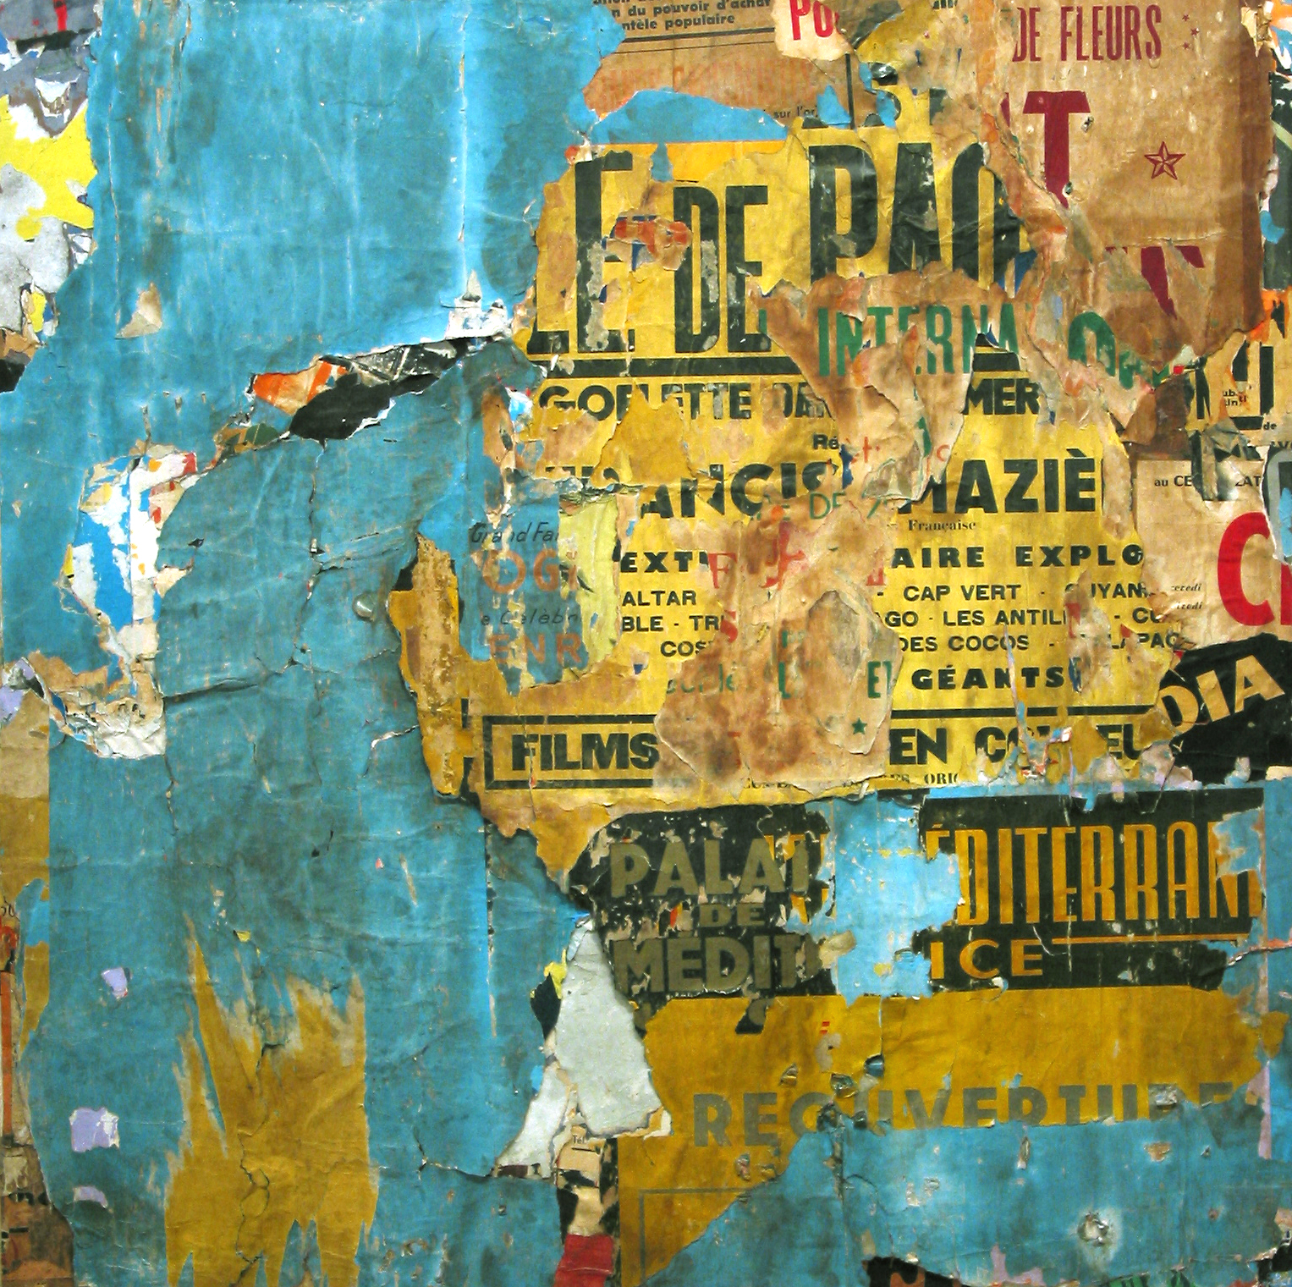  “Voie privée Raspail, Nice”, by Jacques Villeglé  Of all the artistic phenomena associated with Pop art, only Villeglé's décollage has truly managed to move with history as it has happened.  Jacques Villeglé: Décollages, 1965-2006: Torn posters mounted on canvas. Through June 28. Modernism, 685 Market St., San Francisco. (415) 541-0461, www.modernisminc.com.

