Naomie Kremer @ Modernism

by David M. Roth
Posted on 23 February 2018

Naomie Kremer: “Untold” @ Modernism through March 3, 2018.

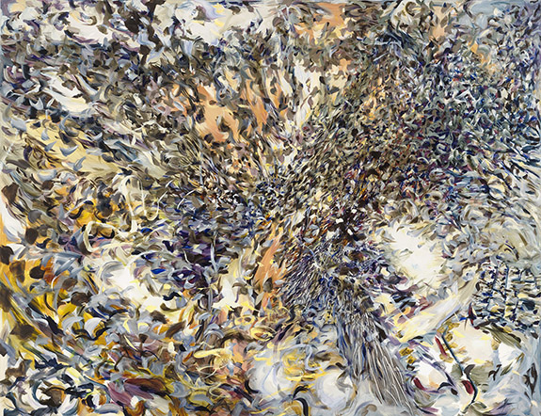
"Qubits," 2016, oil on linen, 51 x 65 1/2 inches

Naomie Kremer seeks nothing less than to give viewers a front-row seat at the dawn of creation. Using a gestural automatism rarely seen these days, Kremer makes paintings that depict nature whipped to frenzy by unseen forces. Her mostly large-scale canvases, ranging in size from 30 x 60 to 62 x 138 inches, churn with eddies and cross currents interrupted by voids and impenetrable thickets. Executed in thin oil paint, these elements sweep across canvases with maelstrom force. As with fractals, the information conveyed isn’t enhanced or diminished by viewing distance; it’s compounded, opening out continuously into vistas likely to leave viewers hopelessly (and pleasurably) lost.

As a group, Kremer’s works bring to mind the voluptuous opening scene in Angels and Insects, the 1995 film based on A.S. Byatt’s novella, Morpho Eugenia (1992), in which the main characters, played by Kristin Scott Thomas and Mark Rylance, fall vertiginously in love against a backdrop of swaying foliage and swarming butterflies. The film’s intoxicating visuals are roughly analogous to those seen in Kremer’s paintings and “hybrid” videos — works in which she projects moving digital images across paintings to make them writhe like living things.

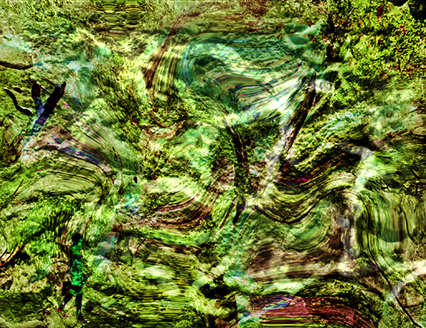
The exhibition, titled Untold, divides evenly, between these two forms, allowing viewers to shift between painted canvases (i.e. those with no video component) and those that serve as backdrops for moving images. The latter, while decidedly filmic in character, still retain something of their identity as static objects, making for true hybrids whose only contemporary counterparts are the purely digital “paintings” of Clive McCarthy (works whose only physical components are the monitors on which they appear) and the equally engrossing hybrid analog/digital paintings of Amy Ellingson. It’s in this realm that Kremer’s conceptual innovations are at their most potent. To fully appreciate them, it’s best to immerse yourself the non-video works first, the better to appreciate how radically they change when subjected to animated overlays.
Still from "Earthborn," 2018-18, CNC bas relief carving + video, 52 x 65 x 8 inches

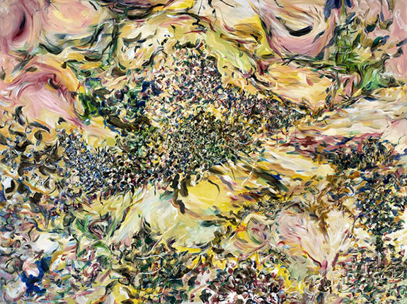
It’s tempting to see these “unmediated” canvases – the source material for the hybrids — as merely reheating the allover techniques of Pollack and de Kooning (the latter especially); but when you look closely, the dominant feel is of an organic Cubism, achieved without interpenetrating planes. Kremer fosters the illusion of multiple perspectives by linking clusters of loose and tightly knit brushstrokes in patterns whose clashing rhythms vary enormously within any single canvas. The feel is of colliding force fields. At a distance, their resplendent colors coalesce into dominant shades (verdant greens, dusky red-tinged dark browns and flaming yellows), only to dissolve on close inspection into their component hues, the apprehension of which require considerable time and labor. In Axis Mundi and Qubit, two stunning works inspired by the artist’s travels to Peru, the effect is kaleidoscopic, as if the colors and shapes had been spun from a centrifuge.

The one painting in the show that breaks from this mold is Upstage. Swirling amoeba and floral shapes burst through a multi-planar grid. The look is of a mirrored office tower invaded by jungle foliage. The view, from the interior looking out, is severely fractured, so much so that spatial reckoning is rebuffed at every turn by the unfolding of successive “rooms,” each opening out into others. It’s an excellent prelude to (and primer) for Kremer’s videos.
“Axis Mundi," 2016, oil on linen, 58 1/2 x 76 3/4 inches
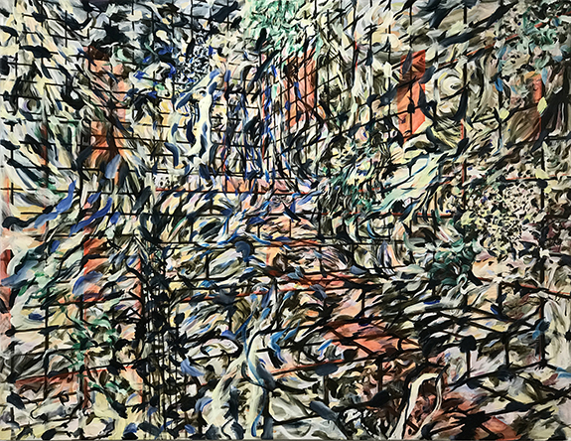
In these, the implied action in the paintings is physically manifest. To watch is to be struck by ontological and epistemological questions to which there are no answers. The strongest example is Earthborn, wherein silhouettes of a walking figure (that of the artist), are projected against a carved bas relief along with what appear to be digitized samples from a painting. The latter flatten into whirling streams of liquefied green matter that call to mind primordial soup, the microbial swamp out of which life supposedly arose. (In this, Bay Area viewers may recognize a close counterpart in the work of video artist Jim Campbell who, several years back, engaged in a similar experiment that viscerally conjured breaking waves by projecting shadow images onto a lumpy cast-resin slab.) Complicating the piece further is an additional overlay of untranslated Hebrew characters — a reference, I presume, to the artist’s Israeli birthplace and to Genesis, which the artist recalls her father reading to her as a child.

"Upstage," 2017 oil on linen, 65 x 50 inches

For Kremer, nature is the springboard for abstraction. She rejuvenates it by placing total faith in her own gestural impulses. Carried forward in video feedback loops that both break apart and reconstruct the source material, they deliver Abstract Expressionism into the digital present.
# # #
Naomie Kremer: “Untold” @ Modernism through March 3, 2018.

About the author:
David M. Roth is the editor and publisher of Squarecylinder.

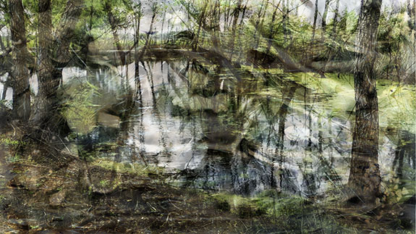
Still from "Riverine," 2017-18, oil on linen + video, 36 x 60 inches

