IN THE FRAME

Origin of the World 2.0 for the age of Trump
by THE ART NEWSPAPER | 6 April 2017

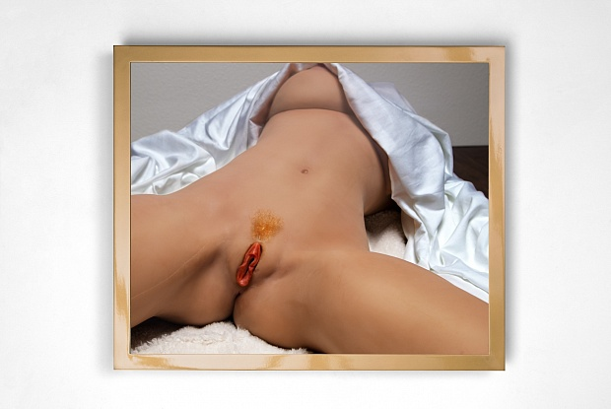

The American artist Elena Dorfman has given a 21st-century twist to Gustave Courbet’s realist painting L’Origine du monde (Origin of the World, 1866), a view of a naked woman, her legs parted, that still has the power to shock audiences—and provoke censorship—a century and a half after its creation. In her latest series of works, The Origin of the New World, Dorfman has photographed silicone sex dolls posed in the same manner as Courbet’s model—though with a more explicit and, ironically, “anatomically correct” view of the vulva—and displayed the images in individual light boxes behind one-way mirrors. An exhibition opening today, 6 April at the San Francisco gallery Modernism (until 20 May) will present eight works from the series, featuring dolls with a variety of skin tones—and sporting an assortment of pubic hair styles. Dorfman says she hopes the works highlight issues such as “the rapid advances in technology that are being used to create female doppelgängers, the cornucopia of pornography that is instantly available on a phone and, of course, the new US president, who rates women on a scale of one to ten and whose free-flowing sexist comments are front-page news worldwide”.

