FOR IMMEDIATE RELEASE
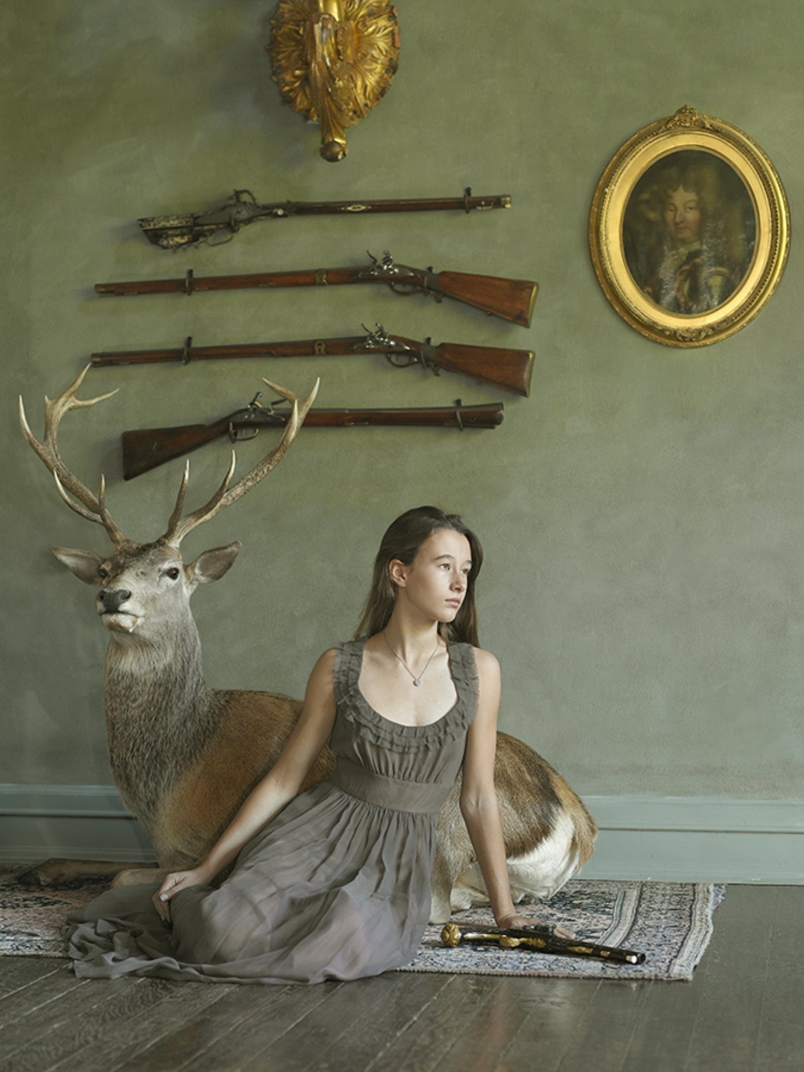
Gallery Exhibition Schedule

Lindsay McCrum: Chicks with Guns
January 10 – February 23, 2019

Chicks with Guns is a compelling cultural portrait of women firearm owners in America. In the era of both #MeToo and pervasive gun violence in the United States, Lindsay McCrum has created a timely series of powerful and unexpected portraits. The work examines issues of self-image and gender through the visual conventions of portraiture and fashion. McCrum neither glorifies nor vilifies her subjects but finds an elusive diversity. The firearms presented here are not superimposed props but the very personal accessories of the women portrayed. And it defies stereotypes often associated with the popular culture of both guns and women. Like the 15-20 million women gun owners in this country, the women we meet in Chicks with Guns (their portraits are accompanied by their own words), reside in all regions of the country, come from all levels of society, and participate seriously in diverse shooting activities. The women here are sportswomen, hunters, and competition shooters. Some use firearms in their jobs and some for self- defense. In these photographs, all the women exude confidence, poise, and power. They are real women with real firearms that play a part in their lives. By focusing her camera respectfully on this particular aspect of the American scene, gun- wielding women and girls, Lindsay McCrum sheds light on who we are in America today.
Greta, Napa Valley, CA, English Forsyth system scent bottle pistol, 2011, archival pigment print, 40 x 30 inches

Modernism is proud to present its first one-person exhibition of photographs by Lindsay McCrum. The exhibition is accompanied by a hardcover book (Vendome Press).

Lindsay McCrum is a fine art and portrait photographer residing in San Francisco and New York City. She received her undergraduate degree from Yale University in 1980 and her Masters of Fine Arts from the San Francisco Art Institute. Trained as a painter in oils, McCrum switched exclusively to portrait photography in 2003. Her photographic projects include 25/50, an exploration of aging in the faces of men; Superheroes and Commandos, a study of boys, costumes and popular culture; and Dress Up, an examination of young girls and the shaping of contemporary notions of fashion and beauty. McCrum’s photographs have been exhibited in galleries in the US and Europe.

The public is cordially invited to attend an opening reception on Thursday, January 10th, from 5:30-8PM.

FOR FURTHER INFORMATION CALL: 415/541-0461 / FAX: 415/541-0425, OR EMAIL TO: INFO@MODERNISMINC.COM. HI-RES IMAGES AVAILABLE ON REQUEST.

