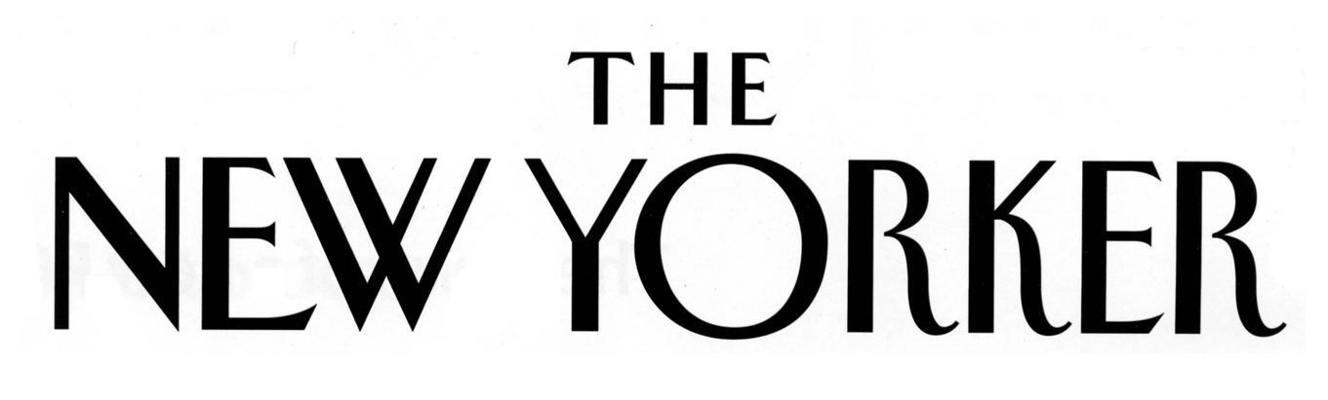

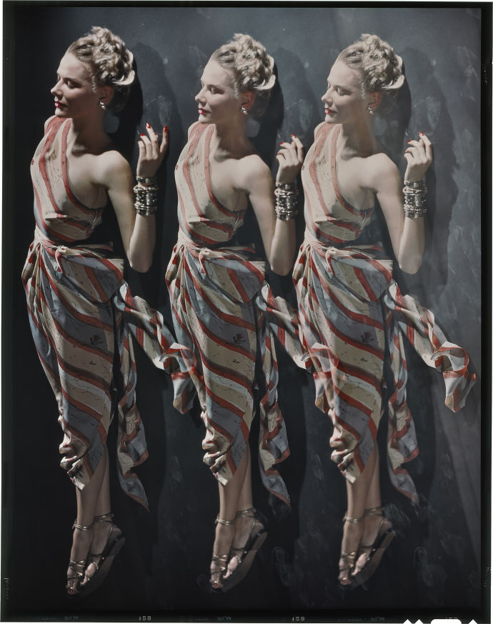
September 15, 2014

Erwin Blumenfeld’s Studio

By Genevieve Fussell
This week, on the heels of New York Fashion Week, the magazine published its latest Style Issue. As we prepared visuals, I was reminded of one of the most stylish photographers of the twentieth century, Erwin Blumenfeld.

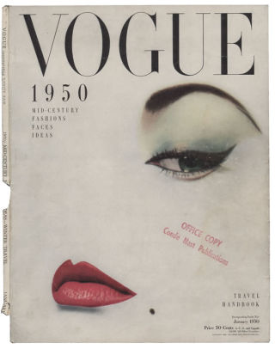
Born in Berlin in 1897, Blumenfeld drew early inspiration from the Dadaists, incorporating experimental techniques like solarization, multiple exposures, and photomontage into his darkroom practice. Blumenfeld, who was Jewish, was imprisoned at a series of camps during the Second World War before fleeing with his family to New York in 1941. With an introduction from Cecil Beaton, Blumenfeld began taking fashion photographs for Vogue and, over time, reputedly became the highest-paid photographer in the industry.*
Blumenfeld felt stymied by art direction, however, and continued to create more experimental work while handling fashion commissions. In a 1948 issue of Commerce Camera, he wrote, “Photography is a means of creating images, and, as such, it need not confine itself to dull records of ham sandwiches, or vacuous girls with paint. Unfortunately, there is a mistaken feeling among some of those who decide what people shall see that nobody but a select few cares to view anything but dull records.”

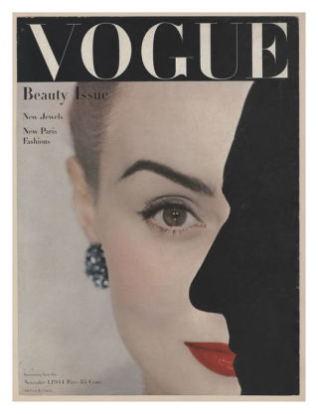
His granddaughter Nadia Blumenfeld-Charbit remembers the decadent atmosphere in his studio, at 222 Central Park South, where he hand-printed photographs of famous subjects like Marlene Dietrich and Audrey Hepburn. The studio was replete with bulb-framed mirrors, bowls filled with costume jewelry, and lipsticks. “He came and went, his bowtie undone, nails bitten down to blood, scissors and pencils at hand,” she recalled.
When Blumenfeld died, in 1969, his work was divided among his three children and his former assistant (and longtime mistress), Marina Schinz. Years of family bickering threatened the integrity of Blumenfeld’s archive, but, in recent years, his grandchildren have worked together to preserve his legacy, producing a Web site as well as a soon-to-début documentary film. Blumenfeld-Charbit has been restoring hundreds of Ektachromes and Kodachromes, badly damaged from years of improper storage, as well as digitizing and printing photographs for exhibition.

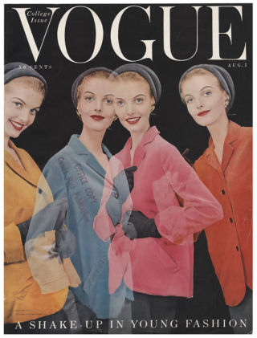
Blumenfeld remains a significant influence on photographers like Pari Dukovic, The New Yorker’s staff photographer. For Dukovic, Blumenfeld’s gifts stemmed from an acute sensitivity to his subjects and his ability to bring “strong technical skills into a visual without making the photograph about the technique.” Of his own work, Blumenfeld wrote in his autobiography, “Eye to I”:
I was an amateur—I am an amateur—and I intend to stay an amateur. To me an amateur photographer is one who is in love with taking pictures, a free soul who can photograph what he likes and who likes what he photographs. By that definition I am an amateur, so that is the definition that I accept.
“Blumenfeld Studio: New York, 1941-1960” is currently on exhibit at 10 Corso Como in Shanghai, and will travel to the Museum of Brazilian Art, in São Paulo, in October.

